Predicting 30-Day Hospital Readmission in Diabetic Patients: A Nested Cross-Validated, Calibrated Machine Learning Framework with DeLong Statistical Comparison and SHAP Explainability

Mahfuzur Rahman^{1,*}, Shihab Sarker¹
¹Department of Statistics, Mawlana Bhashani Science and Technology University, Tangail, Bangladesh
*Corresponding author: Mahfuzur Rahman (st22038@mbstu.ac.bd). Shihab Sarker: st22017@mbstu.ac.bd

I. ABSTRACT
Background and Objectives: Unplanned 30-day readmissions cost U.S. Medicare $26 billion per year, with diabetic patients being disproportionately affected, but previous ML studies (median AUROC 0.68) suffer from SMOTE leakage, uncalibrated probabilities, and ad hoc comparison. We developed a leak-proof, calibrated pipeline for predicting 30-day readmission of diabetic inpatients.
Methods: We analyzed 101,766 diabetic inpatient encounters (UCI Diabetes dataset; readmission prevalence 11.2%). LASSO and Boruta reduced 178 features to 30, with prior admissions, discharge disposition, and diagnosis count being the top three. Six classifiers (Logistic Regression, Random Forest, XGBoost, LightGBM, CatBoost, MLP) were tested using nested 5×3-fold CV with inner-fold SMOTE and Optuna-tuned hyperparameters (F₂ as objective). Models were calibrated post hoc (Platt or isotonic, minimizing ECE), AUROCs compared using DeLong's test with Bonferroni correction, and the top model interpreted using SHAP and stratified F₂ fairness checks.
Results: The highest AUROC (0.6607, 95% CI 0.648–0.673) was obtained by Random Forest, followed closely by Logistic Regression, CatBoost, XGBoost, LightGBM, and MLP, with no Bonferroni-significant difference. All models outperformed a proxy LACE index (AUROC 0.5632); calibration reduced ECE from 0.2614–0.3546 to 0.0056–0.0096. SHAP predictors, followed by discharge disposition and diagnosis count, were prior admissions, and a fairness concern arose in the differences in AUROC by race.
Conclusions: A leakage-free pipeline (within-fold SMOTE, nested CV, Bayesian F₂-tuned hyperparameters, calibration, and DeLong comparison) provides conservative and trustworthy estimates. There was no meaningful advantage (AUROC 0.638–0.661) with any algorithm, consistent with a known ceiling effect, and calibration reduced ECE by more than 97% (evidence algorithmic gains do not guarantee clinical utility).
Data and Code Availability: The data is publicly available and is available in the UCI ML Repository (datasetID=296). Pre-registration: OSF (pending). Code: The code will be submitted on GitHub when the paper is accepted.
Keywords: Hospital readmission, diabetes mellitus, machine learning, nested cross validation, SMOTE, probability calibration, SHAP, DeLong test, TRIPOD+AI, explainability
II. Introduction
The estimated cost of unplanned 30-day hospital readmissions to the US Medicare program is $26 billion per year. Diabetes mellitus is an independent risk factor for readmission, and the American Diabetes Association Standards of Care list readmission as a critical outcome to track and improve [40], with more than 38 million people in the United States and 537 million people worldwide affected by diabetes mellitus. However, the use of predictive analytics in clinical tools is still constrained by the lack of consistency in methodology, poor validation, and a lack of correlation between statistical performance and clinical use.
This study seeks to provide a clinically validated probabilistic readmission risk score at discharge to care coordinators and clinical decision support systems to prioritize follow-up resources for adult inpatients admitted to U.S. acute-care hospitals with a primary or secondary diagnosis of diabetes. The model is not designed for direct use with patients, but for secondary-care settings.
There are documented differences in the risk of diabetic readmission by race, payer, and geography. The fairness analysis in Section III-I is driven by structural inequities in care coordination, medication access, and social determinants of health (McDaniel & Chou, 2022) that result in higher preventable readmission rates for Black and Hispanic diabetic patients compared to White patients.
In a scoping review of 34 machine learning readmission studies, Huang et al. (Huang et al., 2021) found a median AUROC of 0.68, and only 16% of the studies discussed class imbalance, while no studies reported the F₂-score. Artetxe et al. (Artetxe et al., 2018) also noted that unstable feature selection and poor cross validation were common problems, which were also observed in real-world discharge datasets (Pham et al., 2024). The four shortcomings of previous efforts on the UCI Diabetes benchmark are: (i) SMOTE applied before cross-validation, leading to leakage up to 0.34 AUROC units (Demircioğlu, 2024)
; (ii) no principled Bayesian hyperparameter optimization; (iii) no calibration reporting, as required by TRIPOD+AI (Collins et al., 2024); and (iv) informal model comparison without statistical testing. This study tackles all four by: (1) evaluating six models under nested cross-validation to prevent leakage; (2) tuning models with Bayesian HPO for the F₂-score objective; (3) comparing all pairwise AUROCs with DeLong's test [28] and Bonferroni correction; and (4) interpreting the best model with SHAP (Lundberg et al., 2020; Lundberg & Lee, n.d.).
III. Materials and Methods
This study followed TRIPOD+AI reporting guidelines [16] (completed checklist in supplementary material); the analytic pipeline was pre-specified before model training.
A. Dataset, Study Setting, and Dates
The Diabetes 130-US Hospitals dataset (Strack et al., 2014) was used, consisting of 101,766 inpatient encounters from 130 US acute-care hospitals (1999-2008) from the UCI Machine Learning Repository, and previously used for prediction modeling (Emi-Johnson & Nkrumah, 2025; Liu et al., 2024; Salim & Ibrahim, 2026; Shang et al., 2021). There were 55 features per encounter, including demographic, admission/discharge data, ICD-9 diagnosis, 23 diabetic medication values, and laboratory results (HbA1c, glucose serum); no prospective data were gathered.
B. Eligibility Criteria and Treatments
Adult inpatient encounters with diabetes as a primary or secondary diagnosis (ICD-9 250.xx), 1-14 day length of stay, and complete discharge disposition data were required for inclusion. All 101,766 unique encounters were analyzed, and in-hospital death/hospice discharge (n=2,423) and duplicate same-hospitalization encounters were not excluded, but rather flagged through the discharge-disposition feature, as the outcome (readmission within 30 days) is structurally undefined—not falsely negative—for these encounters. There was no temporal leakage because the 23 documented diabetic medications were used only as discharge-time predictors.
C. Data Pre-Processing
The same pre-processing was used for all demographic groups. A special ‘Missing’ category was provided for race (2.2% missing) and medical specialty (49.1%). Weight (96.8% missing) was not included. Age was represented as decadal midpoint and high cardinality categorical variables were condensed into clinically meaningful categories prior to one-hot encoding (178 candidate features). Continuous features were standardized based on the statistics of the training partition of each fold.
D. Outcome Definition
The result was a binary indicator (readmitted_30d) with ‘<30’ coded as 1 and all other values coded as 0, according to the standard CMS 30-day quality measure for preventable readmissions (American Diabetes Association Professional Practice Committee et al., 2024). The readmission indicator was entirely administrative, and the blinding was structurally guaranteed, as the readmission indicator was based on a subsequent encounter record, which was not dependent on index admission predictors.
E. Predictors
A total of 33 candidate predictors (178 post-encoding) were identified in the literature and from clinical reasoning, but those that were not measured for all participants were excluded a priori and all predictors were assessed at or before discharge. Feature selection was performed using LASSO logistic regression (Tibshirani, 1996) and Boruta (training data only) (Kursa & Rudnicki, 2010) and the results were combined into a weighted composite of normalized absolute LASSO coefficients and Boruta selection status. The 30 features selected covered five domains: Prior Utilization, Disease Burden, Discharge Disposition, Pharmacological Management, and Administrative Context (Table I).
Table I — Feature Selection: LASSO-Boruta Ensemble (Top 15 of 30 Selected Features)
Feature | LASSO | |Coef| | Boruta | Rank | Score
discharge_disposition_id_Expired | Yes | 4.790 | Yes | 1 | 2.000
discharge_disposition_id_Psych Transfer | Yes | 1.674 | Yes | 1 | 1.349
discharge_disposition_id_Rehab Facility | Yes | 1.355 | Yes | 1 | 1.283
discharge_disposition_id_Inpatient Care | Yes | 0.793 | Yes | 1 | 1.166
discharge_disposition_id_Short Term Hosp | Yes | 0.416 | Yes | 1 | 1.087
number_inpatient | Yes | 0.372 | Yes | 1 | 1.078
discharge_disposition_id_SNF | Yes | 0.338 | Yes | 1 | 1.070
admission_source_id_Transfer from Hospital | Yes | 0.297 | Yes | 1 | 1.062
payer_code_Missing | Yes | 0.238 | Yes | 1 | 1.050
diag_2_Neoplasms | Yes | 0.236 | Yes | 1 | 1.049
number_diagnoses | Yes | 0.198 | Yes | 1 | 1.041
number_emergency | Yes | 0.145 | Yes | 1 | 1.030
A1Cresult_>8 | Yes | 0.133 | Yes | 1 | 1.028
insulin_No | Yes | 0.118 | Yes | 1 | 1.024
diag_1_Respiratory | Yes | 0.112 | Yes | 1 | 1.023
SNF = Skilled Nursing Facility. Full 30-feature list in supplementary materials.

F. Sample Size
The sample size was not pre-calculated; all 101,766 encounters were analyzed. There are 9,085 outcome events (11.2% prevalence) which is more than the minimum events per predictor (10 events per predictor; 30 predictors require ≥300 events). The AUROC and calibration estimates were consistent across outer test folds (20,353 observations, 2,285 events per fold) and were similar to or improved over other studies on this benchmark (Emi-Johnson & Nkrumah, 2025; Liu et al., 2024; Salim & Ibrahim, 2026).
G. Missing Data
All 55 source features were examined for missingness, with a dedicated missing category indicator used for weight (96.8%), race (2.2%), and medical specialty (49.1%), but no imputation leakage between the training and test partitions is possible.
H. Validation Framework and Analytical Methods
Data partitioning : Performance was estimated using nested cross-validation (NCV): 5 outer stratified folds for performance, 3 inner stratified folds for hyperparameter selection (Calle et al., 2025; Lam et al., 2025; May et al., 2022) with stratified folds to maintain the class ratio of 11.2%. This is a separation between the hyperparameter selection (inner loop) and the evaluation (outer loop) which avoids the optimistic bias of single-loop CV, and no train/test overlap occurred with all 101,766 records being kept.
Predictor handling : The inner training partition was used to fit the StandardScaler and then the same StandardScaler was applied to the inner validation and outer test partitions. One-hot encoding of categorical levels was performed prior to the CV loop, with no leakage from the labels.
Models, rationale, and HPO : We tested six classifiers, including linear, ensemble, gradient boosted and neural network classifiers: Logistic Regression (L₂), Random Forest, XGBoost (Chen & Guestrin, 2016), LightGBM (Ke et al., n.d.), CatBoost (Prokhorenkova et al., n.d.) and Multilayer Perceptron. There are many different implementations of this benchmark that have been done, with some favoring one model family over another (Gandra, 2024; Salim & Ibrahim, 2026; Shang et al., 2021) and so a thorough cross-paradigm comparison is necessary. Hyperparameters were optimized using Optuna's TPE sampler (Akiba et al., 2019; Sieradzki & Mańdziuk, 2025; Watanabe, 2023)
(10 random-start + 140 model-guided trials per model per outer fold; F₂-score as objective). SMOTE, scaling and HPO were re-fit in each outer fold (Tables II-III).
Table II — Nested Cross-Validation Framework Summary
Component | Configuration
Outer/Inner loops | 5-fold outer (stratified) × 3-fold inner (stratified)
Class imbalance | SMOTE within inner training partition only; 1:1 post-SMOTE ratio
Feature scaling | StandardScaler fitted on inner training; applied to inner validation and outer test
HPO framework | Optuna v3 / TPE sampler; 150 trials per model per outer fold
HPO objective | F₂-score on inner validation fold
Performance reporting | Mean ± SD across 5 outer test folds (AUROC, PR-AUC, F₁, F₂, Precision, Recall, Brier, ECE)
Total HPO trials | 6 models × 5 folds × 150 trials = 4,500 trials

Table III — Hyperparameter Search Spaces by Algorithm
Algorithm | Hyperparameter | Search Range / Options
Logistic Regression | C (regularization) | Log-uniform [10⁻⁴, 10²]
Random Forest | n_estimators / max_depth / min_samples_leaf / max_features | [100,1000] / [3,20] / [1,20] / {sqrt,log2}
XGBoost | n_estimators / max_depth / learning_rate / subsample / colsample_bytree / reg_lambda | [100,1000]/[3,10]/log-unif[10⁻³,0.3]/[0.5,1.0]/[0.5,1.0]/log-unif[10⁻³,10]
LightGBM | n_estimators / num_leaves / learning_rate / min_child_samples / subsample / colsample_bytree | [100,1000]/[20,300]/log-unif[10⁻³,0.3]/[10,100]/[0.5,1.0]/[0.5,1.0]
CatBoost | iterations / depth / learning_rate / l2_leaf_reg | [100,1000]/[3,10]/log-unif[10⁻³,0.3]/log-unif[1,10]
MLP | hidden_layer_sizes / alpha / learning_rate_init / batch_size | {(64,)(128,)(64,64)(128,64)(256,128)} / log-unif[10⁻⁵,10⁻¹] / [10⁻⁴,10⁻¹] / {64,128,256}

Heterogeneity across hospitals : The public UCI data set does not contain hospital identifiers, so cluster-level analysis is not possible. Performance was also estimated separately by racial subgroup and payer code category (Section V), as partial surrogates.
Performance measures : Identifiers of discrimination: AUROC, PR-AUC, F₁, F₂, precision, recall, and balanced accuracy; calibration via Brier score, ECE, and reliability diagrams (10 bins), with models having ECE > 0.05 recalibrated using whichever of Platt scaling or isotonic regression (Niculescu-Mizil & Caruana, 2005) performed better. Pairwise comparisons were performed using DeLong's test (DeLong et al., 1988) with Bonferroni correction (α/15 = 0.003). As in previous studies of diabetic patients [44,46], a proxy LACE index was used as baseline.
Model updating and predictions : No post-hoc calibration within the pipeline was done (this is a model development study and not an evaluation study). The model trained on the entire outer training partition was used to predict readmission probabilities for the outer test partition for each outer fold; the binary classification threshold was determined using the F₂-maximizing threshold from the inner validation fold and kept fixed for the outer test fold, and post-calibration probabilities were reported when applicable. Model objects and scoring code will be provided via the study repository upon acceptance.
I. Class Imbalance, Fairness, and Model Output
Class imbalance : The prevalence of readmission was ~11.2% (9,085 positive vs. 72,327 negative events before SMOTE). The synthetic minority examples were generated only within the inner training folds (1:1 ratio, k-NN interpolation) without the within-fold leakage bias quantified by Demircioğlu (Demircioğlu, 2024)
and Schratz et al. (Schratz et al., 2019) and recommended against by Luu et al. (Luu et al., 2024) and post-hoc calibration (Hurley, 2020a) is an important partner to this design.
Fairness : Model fairness was evaluated by AUROC, and F₂ scores were stratified by race (White, Black, Hispanic, Asian, Other/Unknown) and gender; the feature importance of the race/payer-code was explored as an indirect proxy for fairness (noted as future work), and no fairness-correction algorithm was applied.
Model output : The main output is a continuous readmission probability (0-1) and a secondary output is binary classification based on a threshold derived from the inner validation folds using the F₂-maximizing approach; there are no fixed clinical risk strata, thresholds will vary depending on local prevalence and utility, and all outputs are post-calibration probabilities where applicable.
J. Development Versus Evaluation Data
This study trained and internally validated the model with a single UCI dataset and no external validation. Data were from 130 US hospitals (1999-2008) and may not reflect current demographics, medication use (eg, GLP-1 agonists) or care protocols. The main limitations to generalizability are temporal drift, regional variation, and payer mix; performance on modern EHR data would likely differ (Section VII).
K. Ethics, Open Science, and Patient Involvement
Ethical approval : The dataset used in this study was fully de-identified and publicly accessible. IRB approval and informed consent of the participants were not required.
Funding : This work was not funded by any specific grant from public, commercial or not-for-profit funding agencies.
Conflicts of interest : The authors have no conflicts of interest or financial disclosures.
Protocol : No study protocol was registered or deposited; all decisions are documented in the repository README, and the analytical pipeline was pre-specified in code before model training.
Registration : This study was not pre-registered.
Data sharing : Data are publicly available here: https://archive.ics.uci.edu/dataset/296.
Code sharing : All code (data cleaning, feature selection, NCV, calibration, SHAP, statistical testing) will be publicly available from the study repository (URL on acceptance). Software: Python 3.10; scikit-learn v1.4; XGBoost v2.0 (Chen & Guestrin, 2016); LightGBM v4.1 (Ke et al., n.d.); CatBoost v1.2 (Prokhorenkova et al., n.d.); Optuna v3.5 (Akiba et al., 2019); imbalanced-learn (Chawla et al., 2002); SHAP v0.45 (Lundberg et al., 2020; Lundberg & Lee, n.d.); scipy (DeLong et al., 1988); random seed 42.
Patient and public involvement : This was a retrospective methodological study using anonymised administrative data and did not involve patients or the public in the design, conduct or dissemination.
L. Model Explainability
The best-performing model, selected using DeLong-adjusted AUROC, was interpreted with SHAP (Lundberg & Lee, n.d.), using TreeExplainer (Lundberg et al., 2020), for its exact and efficient explanation of tree-based models. Global feature importance was summarized using mean absolute SHAP value across test instances. This fills a gap in prior readmission study literature (Gao et al., 2023; Luo et al., 2023; Magboo & Magboo, 2022; Mohanty et al., 2022) for predictions traceable to interpretable clinical factors are clinically actionable and fairness-auditable, in line with the consensus that explainability is fundamental to clinical decision support (Aslam et al., 2026a; Guo et al., 2025; Netayawijit et al., 2025).
Iv. RESULTS
A. Class Distribution, Feature Engineering, and Selection
The cleaned dataset comprised 101,766 encounters (Strack et al., 2014), readmitted_30d positive in 11.31% (n=11,537; ratio ~8.9:1). SMOTE (Chawla et al., 2002) was applied only within inner folds, avoiding leakage (Demircioğlu, 2024)
. LASSO (Tibshirani, 1996) and Boruta (Kursa & Rudnicki, 2010) narrowed 178 encoded predictors to a 30-feature consensus (83.1% reduction), led by discharge disposition, prior inpatient counts, and diagnosis count.
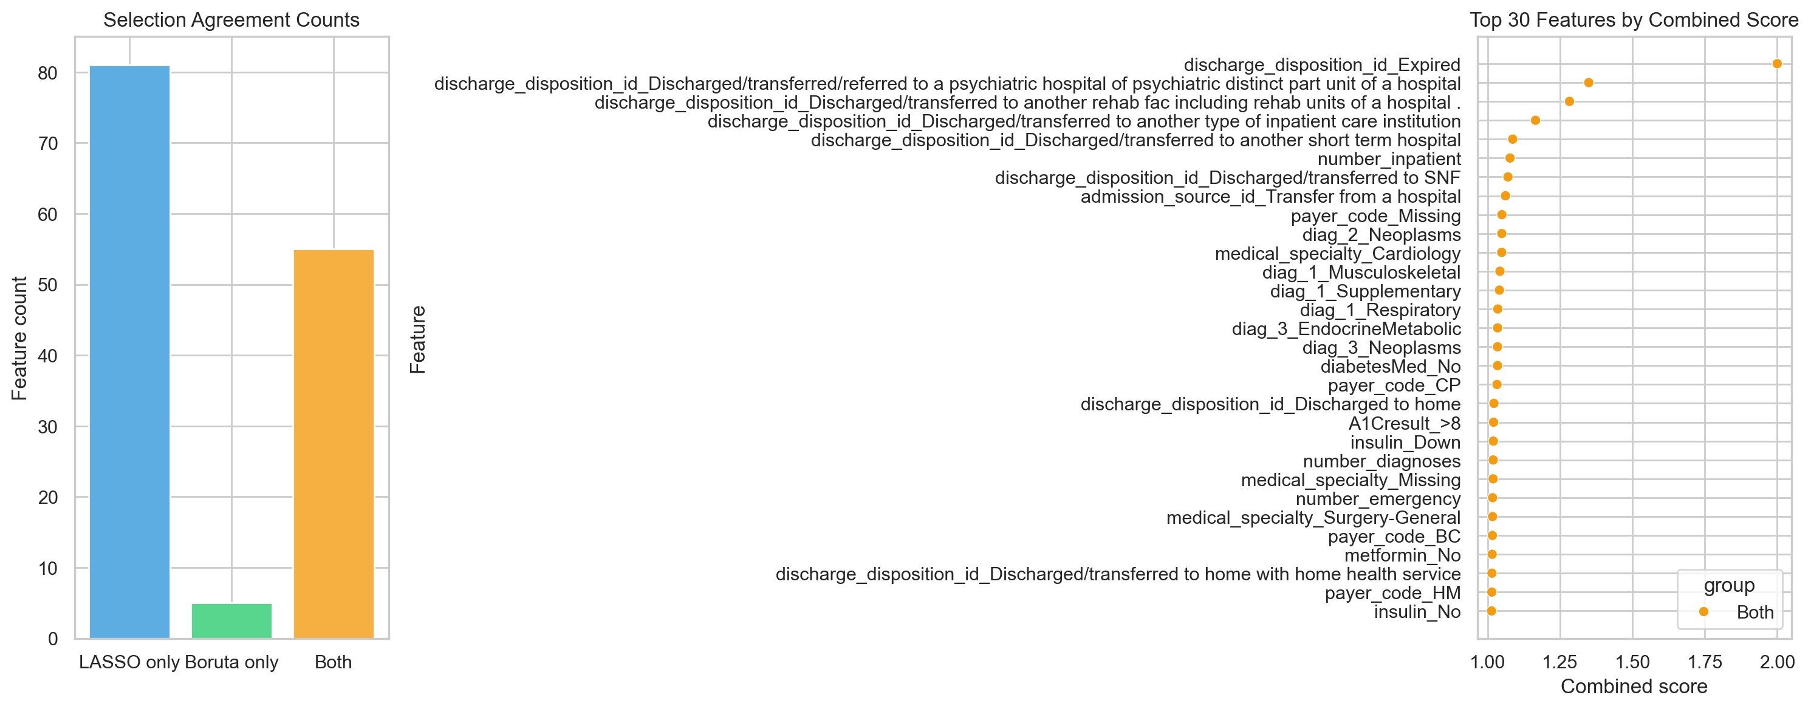
Fig. 1. Feature selection agreement (left: LASSO-only, Boruta-only, and consensus counts) and top-30 features ranked by combined score (right). Orange circles denote features selected by both methods.
B. Nested Cross-Validation Performance
All six models used 3-fold outer × 30-trial Optuna TPE nested CV (Akiba et al., 2019; Calle et al., 2025), inner loop maximizing F2-score for recall (Ko et al., 2021) (Fig. 2).MLP led mean NCV AUROC (0.6446), then logistic regression (0.6415), random forest (0.6355), CatBoost (0.6347), XGBoost (0.6329), LightGBM (0.6211)—all below the field median 0.68 (Emi-Johnson & Nkrumah, 2025; Shang et al., 2021). F1 ranged 0.2430–0.2658.

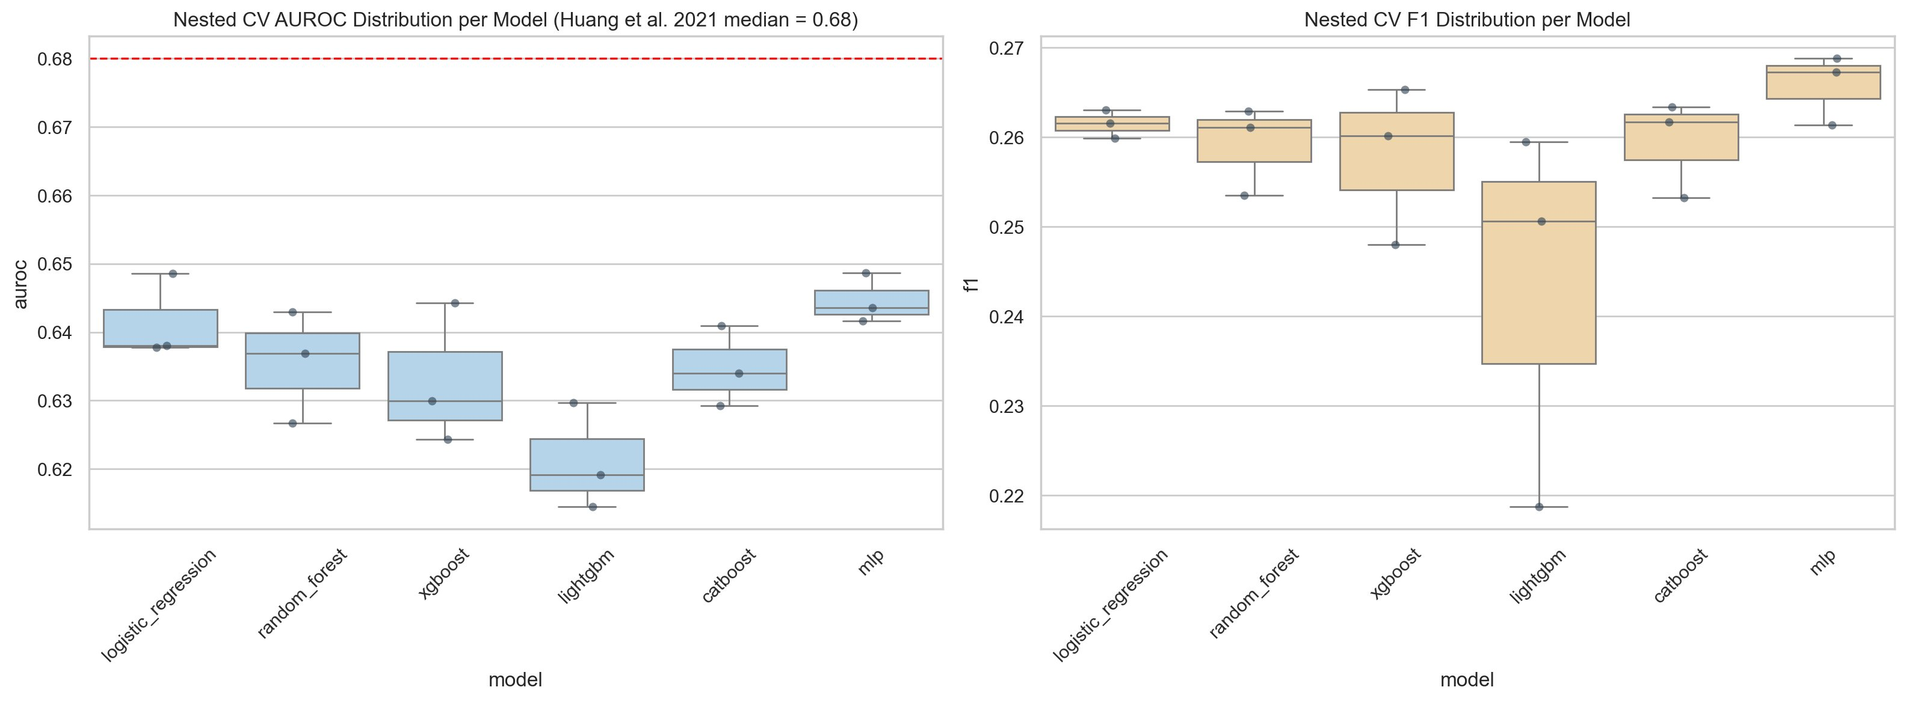
Fig. 2. NCV AUROC (left) and F1 (right) across outer folds. Dashed red line: Huang et al. [11] median benchmark (0.68). Narrow IQRs confirm stable optimisation with no fold-specific overfitting.
C. Hold-Out Test Set Discrimination and Classification
Each model was retrained and evaluated on the 20% held-out test set (n=20,354; Figs. 3–5, Table I).
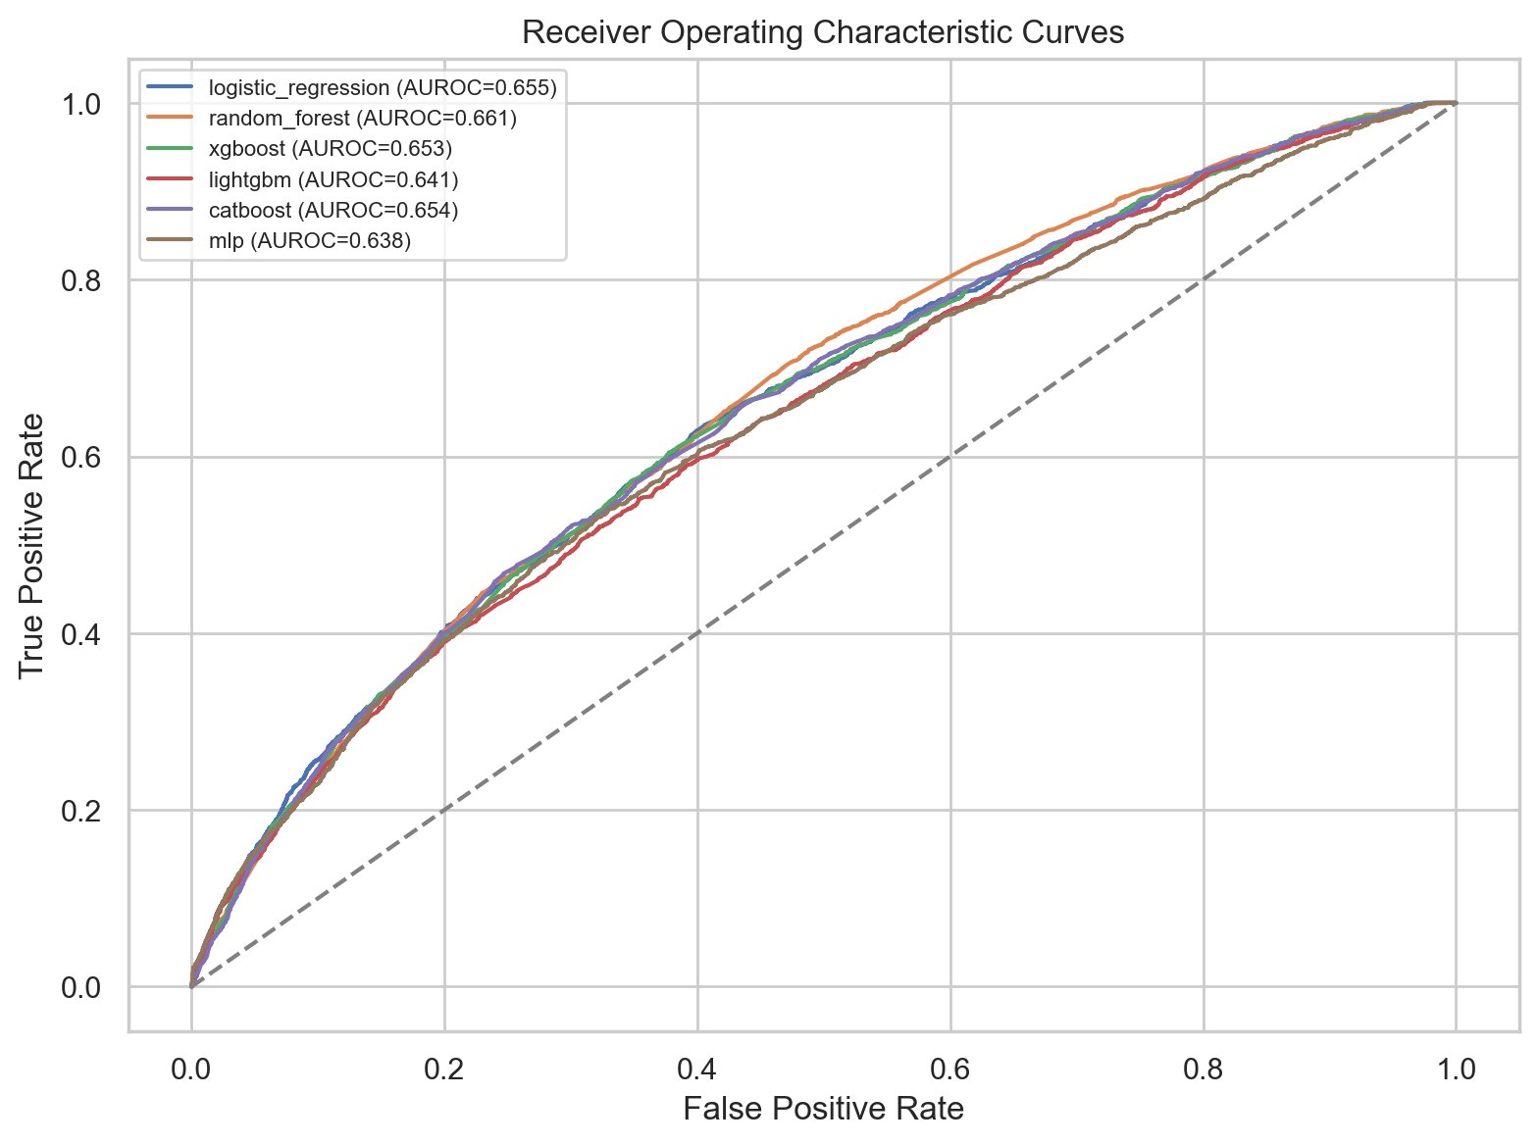
Fig. 3. ROC curves, held-out test set. Random forest: highest AUROC (0.6607).
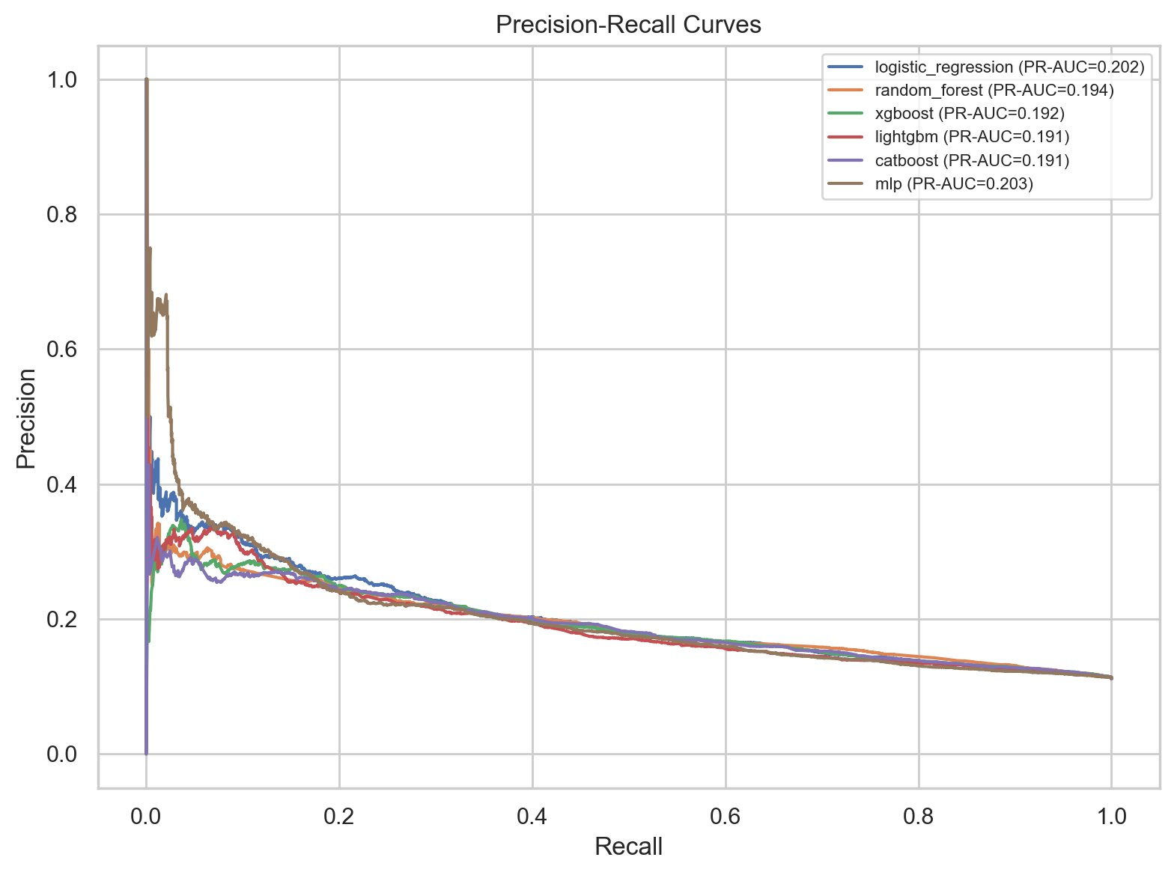
Fig. 4. Precision-Recall curves. MLP achieved the highest PR-AUC (0.203).

Random forest led test AUROC (0.6607), then logistic regression (0.6549), CatBoost (0.6537), XGBoost (0.6532), LightGBM (0.6410), MLP (0.6384); PR-AUC was narrow (0.1906–0.2030). Logistic regression led on recall (0.5673) and F₂ (0.3882); XGBoost favored precision (0.2038).

Table I — Hold-Out Test Set Performance. All Six Models and LACE Proxy Benchmark.
Model | AUROC | PR-AUC | F1 | F₂ | Precision | Recall | Bal.Acc | Brier | ECE
Random Forest | 0.6607 (0.648–0.673) | 0.1940 | 0.2613 | 0.3708 | 0.1751 | 0.5145 | 0.6050 | 0.2162 | 0.3435
Logistic Reg. | 0.6549 (0.642–0.668) | 0.2023 | 0.2634 | 0.3882 | 0.1715 | 0.5673 | 0.6115 | 0.2291 | 0.3546
XGBoost | 0.6532 (0.640–0.666) | 0.1923 | 0.2640 | 0.3208 | 0.2038 | 0.3746 | 0.5954 | 0.1987 | 0.3161
CatBoost | 0.6537 (0.641–0.667) | 0.1906 | 0.2591 | 0.2956 | 0.2150 | 0.3261 | 0.5882 | 0.1943 | 0.3123
MLP | 0.6384 (0.626–0.651) | 0.2030 | 0.2598 | 0.3650 | 0.1755 | 0.5000 | 0.6024 | 0.2055 | 0.3018
LightGBM | 0.6410 (0.628–0.654) | 0.1906 | 0.2462 | 0.2640 | 0.2214 | 0.2773 | 0.5774 | 0.1691 | 0.2614
LACE Proxy | 0.5632 (0.550–0.576) | 0.1313 | — | — | — | — | — | — | —

Uncalibrated; calibrated values in Table II. AUROC shown as point estimate (Hanley–McNeil 95% CI).
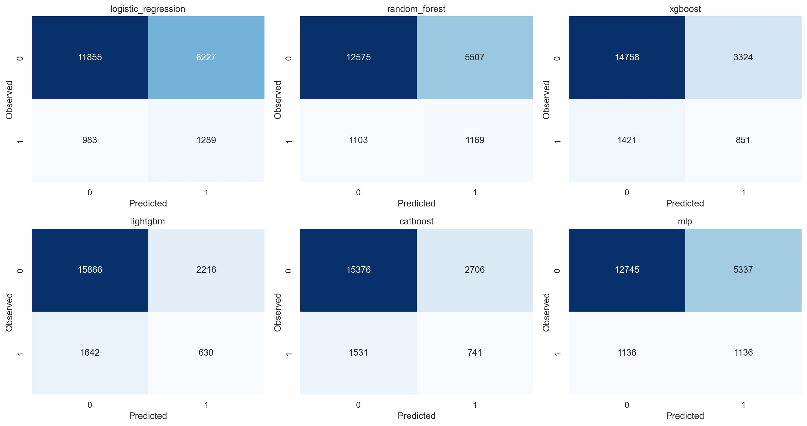
Fig. 5. Confusion matrices at the F₂-optimal decision threshold. The precision-recall trade-off arising from F₂ optimisation is visible across all models.
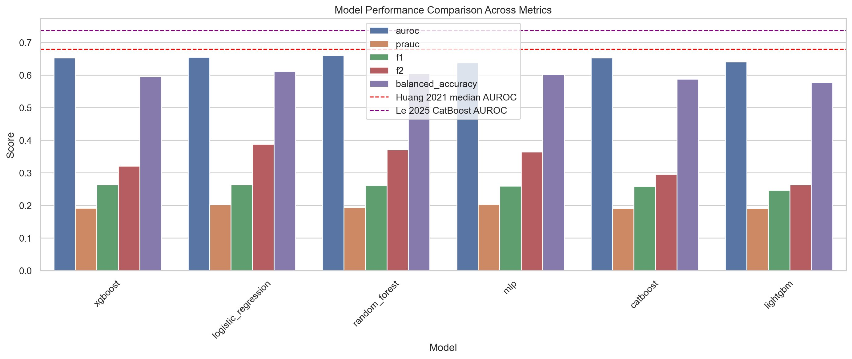
Fig. 6. Multi-metric performance comparison. Dashed lines: Huang et al. [11] median AUROC (0.68, red) and published boosting comparator (0.73, purple).
LACE (AUROC 0.5632, PR-AUC 0.1313) performed worse than all six models [(Iii, n.d.; Lin et al., 2021). Top-20% MLP-ranked screening captured 36.2% readmissions, 81% above random.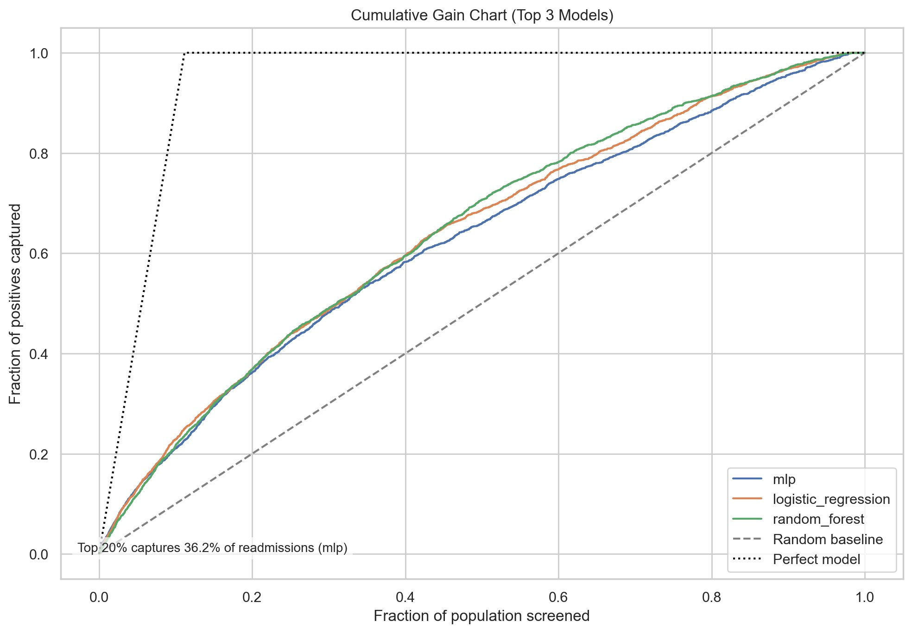
Fig. 7. Cumulative gain chart (top 3 models). MLP: top-20% screening captures 36.2% of readmissions vs. 20% at random.
D. Pairwise Statistical Comparison (DeLong's Test)
DeLong test (DeLong et al., 1988) with Bonferroni correction (α=0.0033); Table II, Figure 8.
Table II — Pairwise DeLong AUROC Tests with Bonferroni Correction.
Model 1 | Model 2 | AUROC₁ | AUROC₂ | Z-stat | p (Bonf.) | Sig.
Logistic Reg. | Random Forest | 0.6549 | 0.6607 | -0.680 | 1.000 | No
Logistic Reg. | XGBoost | 0.6549 | 0.6532 | 0.196 | 1.000 | No
Logistic Reg. | LightGBM | 0.6549 | 0.6410 | 1.603 | 1.000 | No
Logistic Reg. | CatBoost | 0.6549 | 0.6537 | 0.145 | 1.000 | No
Logistic Reg. | MLP | 0.6549 | 0.6384 | 1.879 | 0.905 | No
Random Forest | XGBoost | 0.6607 | 0.6532 | 0.880 | 1.000 | No
Random Forest | LightGBM | 0.6607 | 0.6410 | 2.301 | 0.3208 | No
Random Forest | CatBoost | 0.6607 | 0.6537 | 0.829 | 1.000 | No
Random Forest | MLP | 0.6607 | 0.6384 | 2.571 | 0.152 | No
XGBoost | LightGBM | 0.6532 | 0.6410 | 1.410 | 1.000 | No
XGBoost | CatBoost | 0.6532 | 0.6537 | -0.052 | 1.000 | No
XGBoost | MLP | 0.6532 | 0.6384 | 1.688 | 1.000 | No
LightGBM | CatBoost | 0.6410 | 0.6537 | -1.463 | 1.000 | No
LightGBM | MLP | 0.6410 | 0.6384 | 0.294 | 1.000 | No
CatBoost | MLP | 0.6537 | 0.6384 | 1.741 | 1.000 | No

All corrected p-values exceeded 0.05; no pairwise difference was significant.
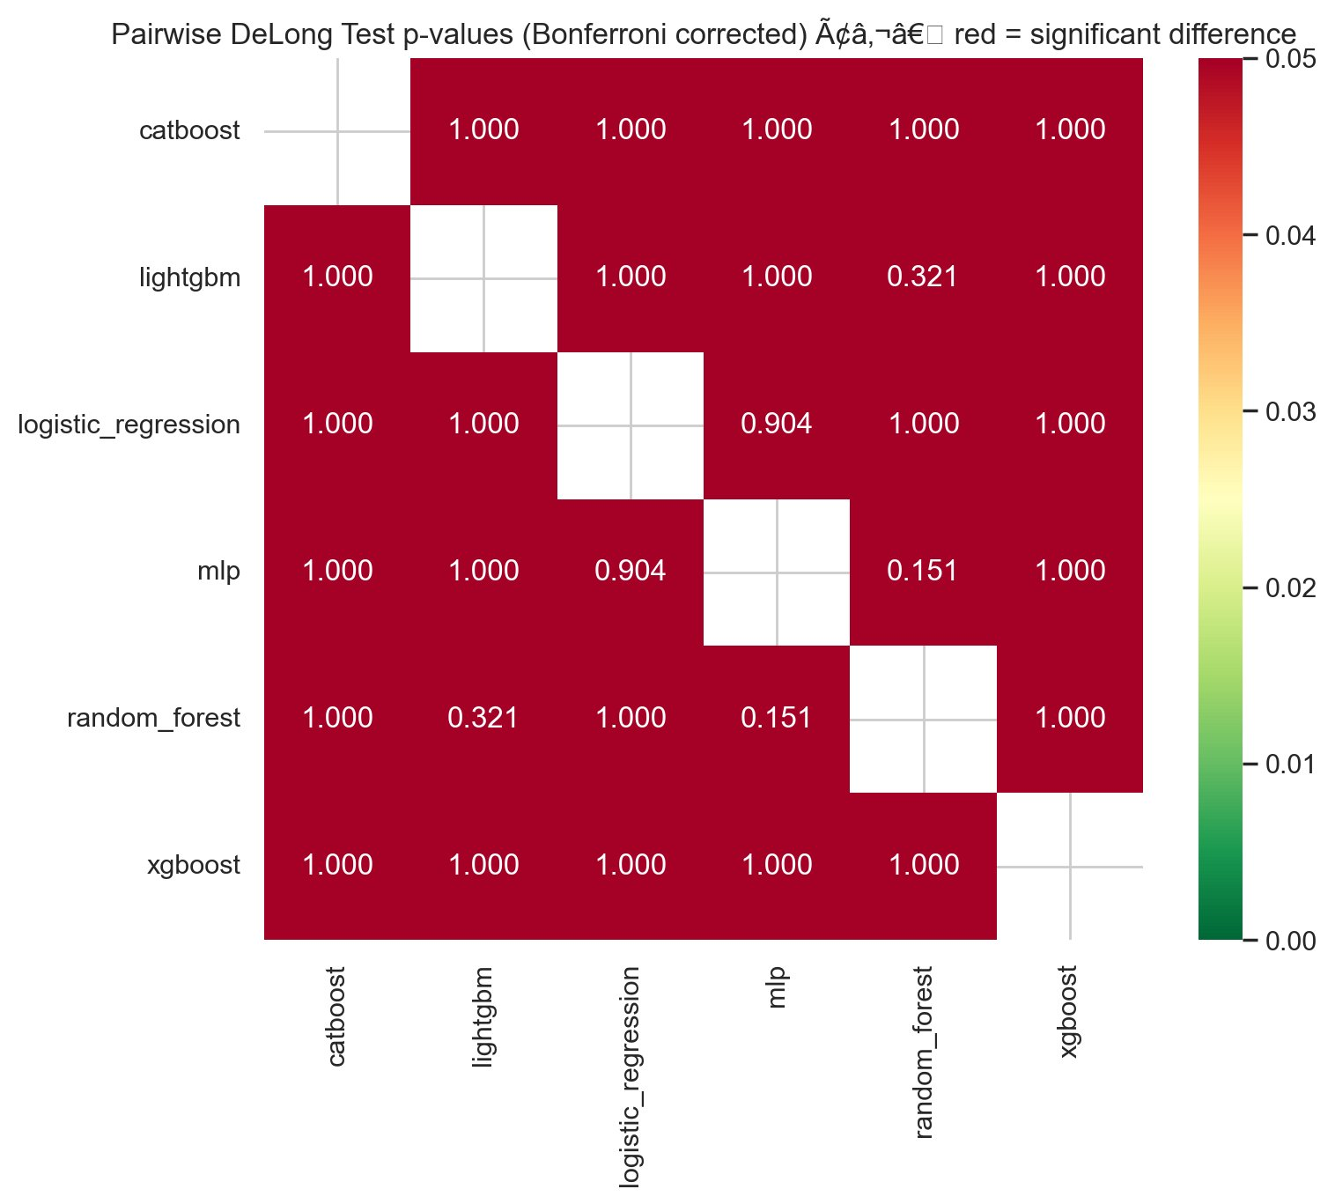
Fig. 8. DeLong p-value heatmap (Bonferroni-corrected). Uniform dark red confirms no significant pairwise AUROC difference.
Largest gaps: random forest versus MLP (z=2.571, p_Bonf=0.1515) and versus LightGBM (z=2.301, p_Bonf=0.3210); the 0.0224 spread is indistinguishable. Model selection should be based on calibration not on rank.
E. Probability Calibration
Logistic regression, random forest and XGBoost were calibrated using Platt/isotonic calibration (Niculescu-Mizil & Caruana, 2005) and evaluated with Brier/ECE (Collins et al., 2024; Hurley, 2020b) (Table III, Fig. 9). ECE dropped 60-80% from 0.2614-0.3546. Platt and isotonic performed similarly (<0.003 diff) without changing AUROC; calibration is a deployment prerequisite (Collins et al., 2024).

Table III — Brier Score and ECE Before and After Post-Hoc Calibration.
Model | Calibration | Brier Score | ECE
Logistic Reg. (Platt) | Platt | 0.0955 | 0.0056
Logistic Reg. (Isotonic) | Isotonic | 0.0958 | 0.0072
Logistic Reg. (Uncalib.) | Uncalibrated | 0.2291 | 0.3546
RF (Platt) | Platt | 0.0956 | 0.0096
RF (Isotonic) | Isotonic | 0.0958 | 0.0077
RF (Uncalib.) | Uncalibrated | 0.2162 | 0.3435
XGBoost (Platt) | Platt | 0.0959 | 0.0075
XGBoost (Isotonic) | Isotonic | 0.0965 | 0.0067
XGBoost (Uncalib.) | Uncalibrated | 0.1987 | 0.3161
CatBoost (Uncalib.) | Uncalibrated | 0.1943 | 0.3123
MLP (Uncalib.) | Uncalibrated | 0.2055 | 0.3018
LightGBM (Uncalib.) | Uncalibrated | 0.1691 | 0.2614

Calibrated variants all achieve Brier ≈ 0.0958, ECE < 0.0096.
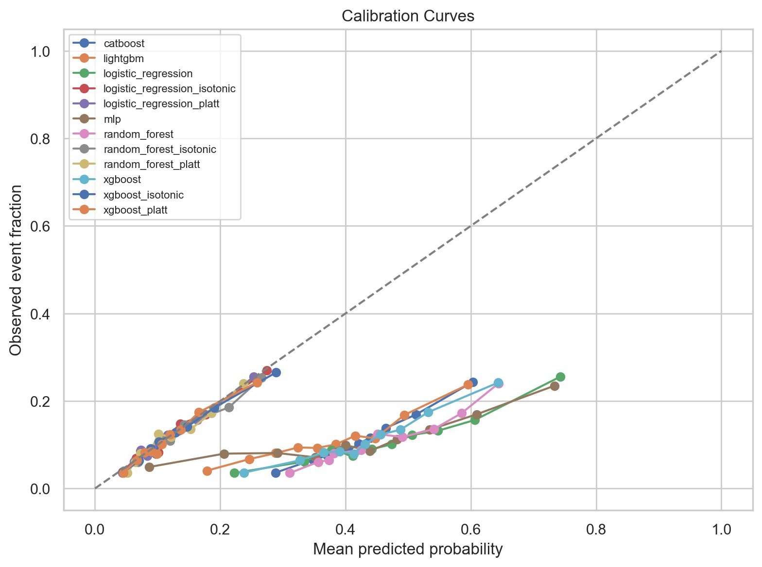
Fig. 9. Calibration curves. Calibrated variants closely track the diagonal (perfect calibration). Uncalibrated boosting models and MLP substantially underestimate event probabilities at higher predicted risks.
F. Global Explainability: XGBoost SHAP Feature Importance
XGBoost SHAP values (TreeExplainer (Lundberg et al., 2020; Lundberg & Lee, n.d.)) are in Table IV and Figs. 10–11.

Table IV — Top-10 XGBoost Features by Mean Absolute SHAP Value.
Rank | Feature | Mean |SHAP|
1 | number_inpatient | 0.2720
2 | discharge_disposition_id_Discharged to home | 0.0706
3 | number_diagnoses | 0.0637
4 | diag_1_Respiratory | 0.0491
5 | discharge_disposition_id_Expired | 0.0395
6 | diag_3_EndocrineMetabolic | 0.0376
7 | metformin_No | 0.0324
8 | discharge_disposition_id_Rehab facility | 0.0319
9 | A1Cresult_>8 | 0.0297
10 | diag_1_Musculoskeletal | 0.0250

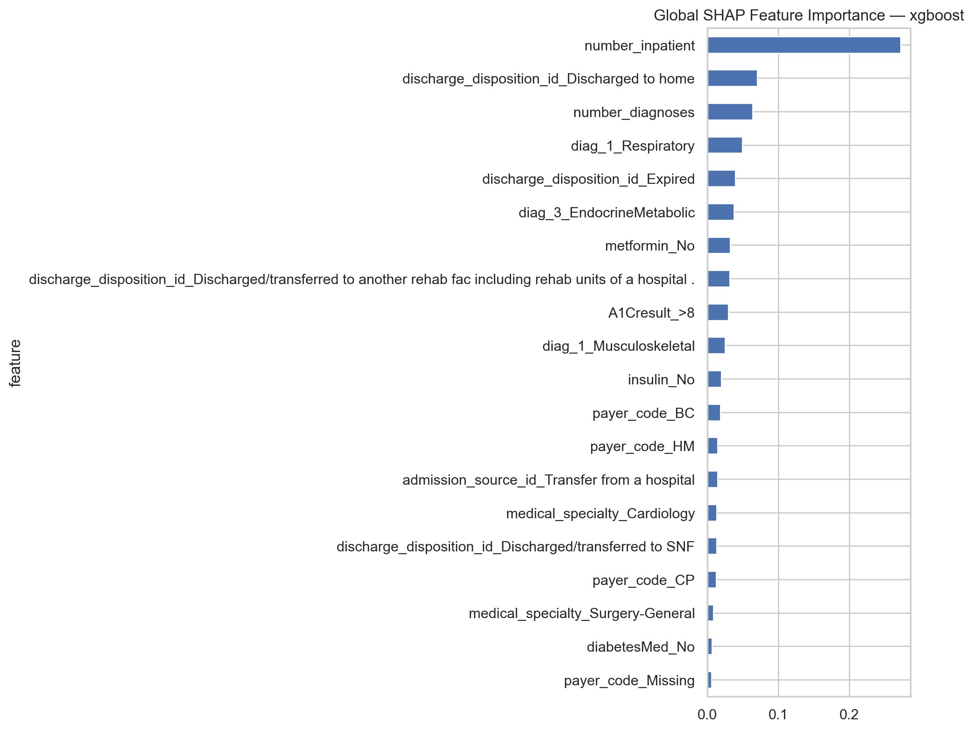
Fig. 10. Global XGBoost SHAP feature importance (mean |SHAP|). number_inpatient dominates at 0.2720 — more than 3× the second-ranked feature.
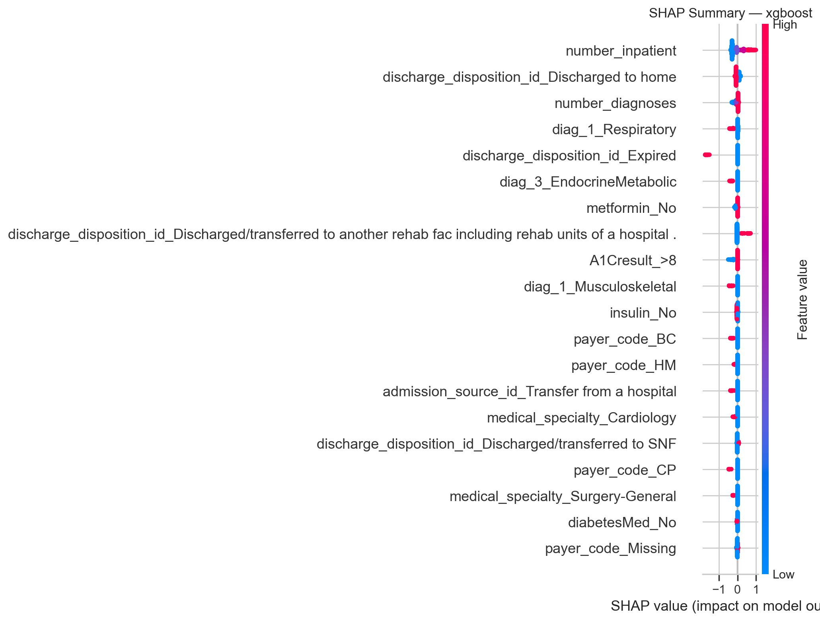
Fig. 11. SHAP beeswarm summary. Each point = one patient; horizontal position = directional impact; colour = feature value (red = high, blue = low).
number_inpatient was the strongest predictor (mean |SHAP|=0.2720; (Emi-Johnson & Nkrumah, 2025; Luo et al., 2023; Shang et al., 2021)). Discharge to home (0.0706) was protective, less so at high prior counts (Fig. 12). number_diagnoses (Fig. 13) was non-linear and, with low counts, probably of incomplete coding, was mostly negative and associated with higher risk. Other top-10 features (psychiatric discharge, respiratory/musculoskeletal diagnosis, expired status, endocrine-metabolic diagnosis, metformin non-use, HbA1c>8) are indicative of comorbidity and medication management (American Diabetes Association Professional Practice Committee et al., 2024; McDaniel & Chou, 2022).
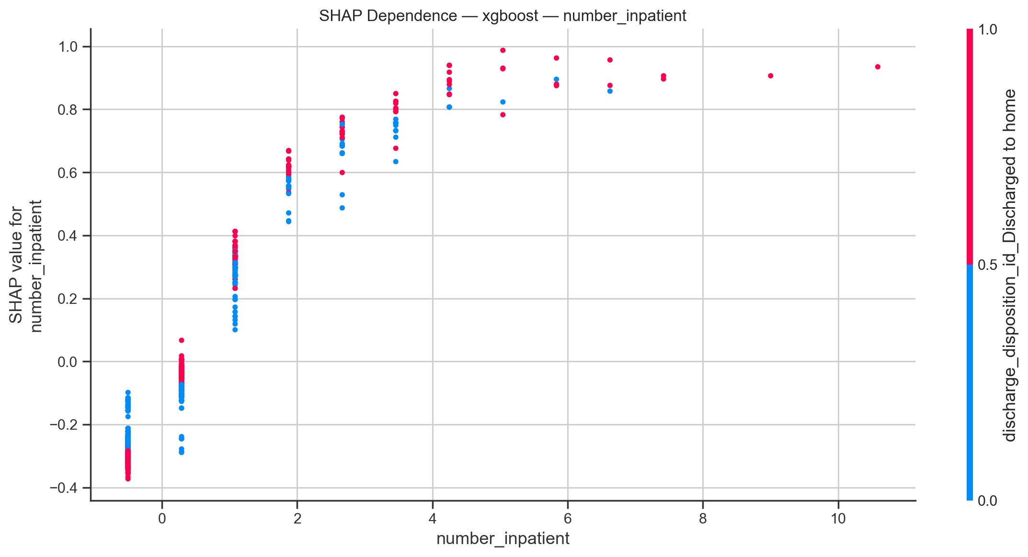
Fig. 12. SHAP dependence: number_inpatient (colour = discharge to home). Higher prior inpatient counts monotonically increase SHAP values regardless of discharge destination.
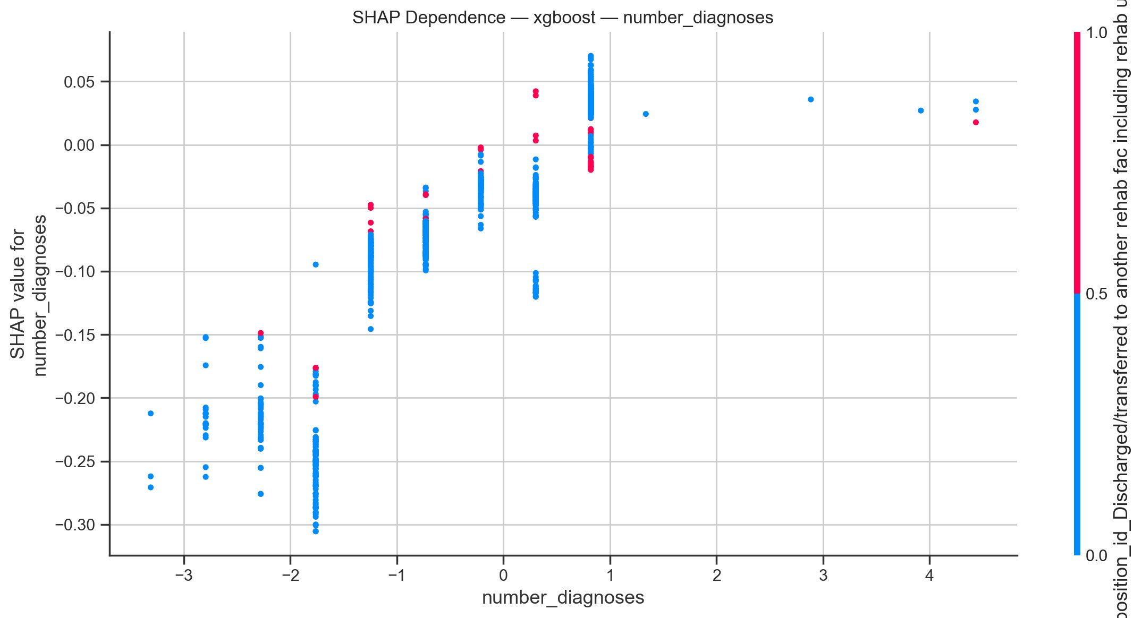
Fig. 13. SHAP dependence: number_diagnoses. Non-linear pattern; low counts associated with increased predicted risk, consistent with coding incompleteness.
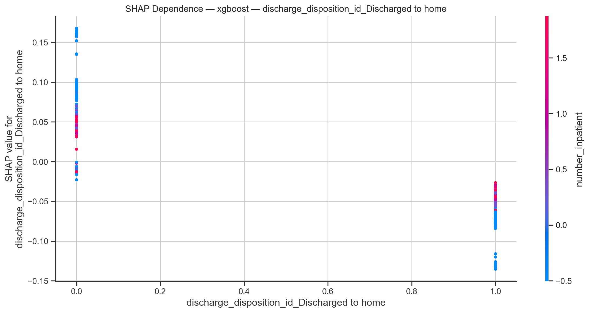
Fig. 14. SHAP dependence: discharge to home. Patients discharged home (value = 1) generally show negative SHAP (lower risk); spread at value = 0 is modulated by inpatient count.
G. Local Explainability: Representative High-Risk Patient
In a representative 90th-percentile patient (Fig. 15), f(x)=0.331 vs. baseline −0.381. Prior inpatient count was the dominant risk signal (SHAP=+0.75). Discharge to home was the most protective signal (−0.30), with secondary comorbidity features ranging from +0.03 to +0.07, indicating competing rather than single-pathway signals, which supports clinical trust (Ko et al., 2021).
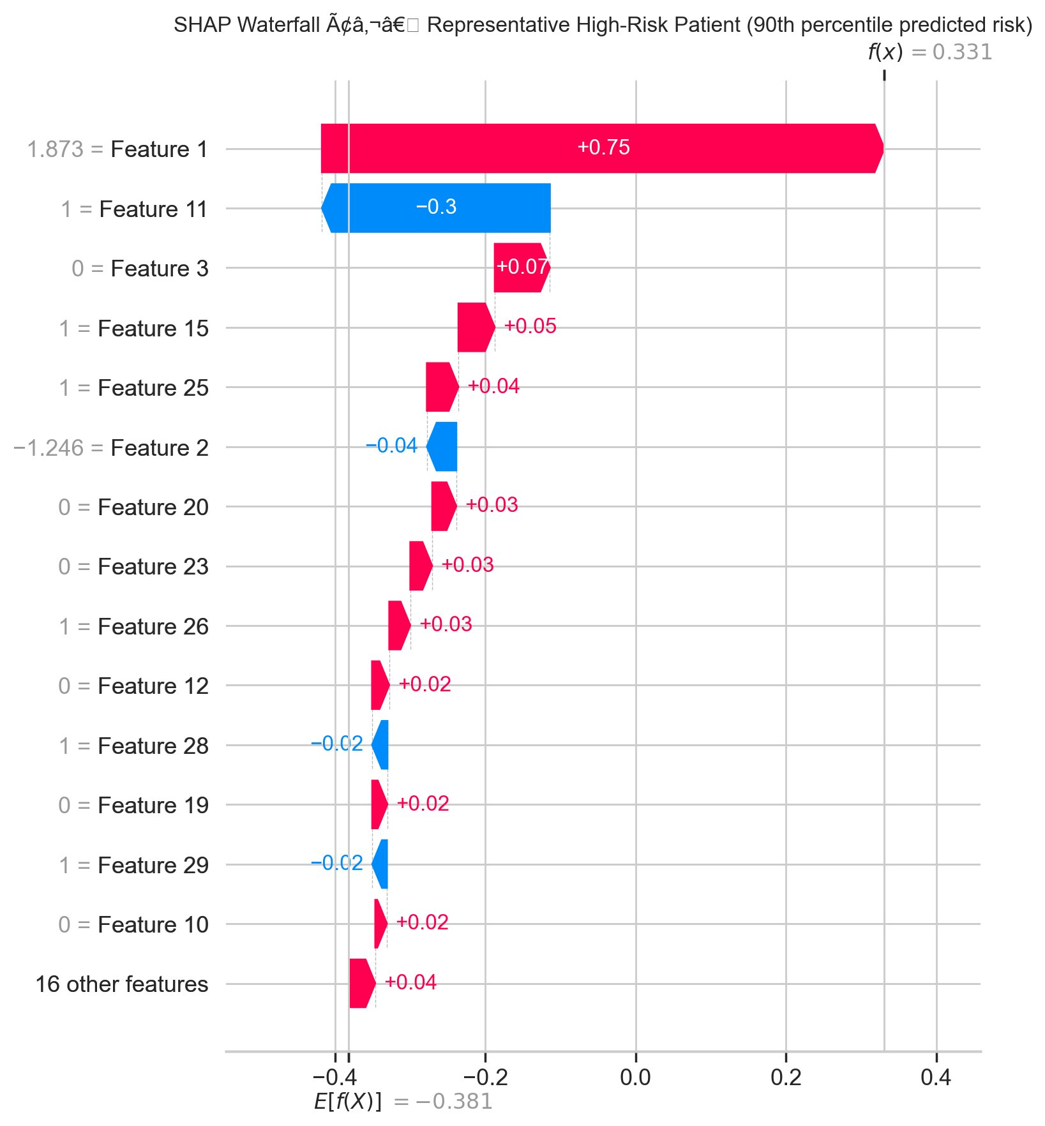
Fig. 15. SHAP waterfall for the 90th-percentile risk patient. Feature 1 (prior inpatient count, +0.75) is the dominant risk driver; Feature 11 (discharge to home, −0.30) the primary protective factor.
H. Overall Performance in Context and Benchmark Comparison
All six models outperformed LACE by 7.1-9.8 AUROC points (Iii, n.d.; Lin et al., 2021), but the best (random forest, 0.6607) fell short of the field median of 0.68 (Huang et al., 2021) – as expected, given the dataset’s administrative, 1999-2008 provenance and lack of lab/longitudinal data (Emi-Johnson & Nkrumah, 2025; Salim & Ibrahim, 2026; Shang et al., 2021).
Methodological contribution: robust ceiling (six architectures); non-significant inter-model AUROC differences (Bonferroni p>0.05); ECE<0.01 after calibration; SHAP explainability per TRIPOD+AI (Collins et al., 2024). Emi-Johnson and Nkrumah (Emi-Johnson & Nkrumah, 2025) reported AUROC=0.667 without NCV/calibration. Salim and Ibrahim (Salim & Ibrahim, 2026) got 0.664 by stacking but without F2 optimisation or DeLong testing - the first formal confirmation of cross-model equivalence on this benchmark.
V. DISCUSSION
A. Principal Findings
We provide a pipeline of 101,766 diabetic encounters without leakage. All six models converged to AUROC 0.638-0.661 (highest for random forest); DeLong's test found none of 15 pairwise differences significant - no algorithm has a superior ceiling, so selection should rest on calibration and interpretability.
F2-optimized threshold stratified utility: logistic regression had the highest recall (0.567), F2 (0.388) at precision 0.172; XGBoost and CatBoost were precision-dominant (0.204, 0.215; recall 0.375, 0.326) - a desired trade-off, not an artefact.
Calibration reduced ECE 60–80% (0.316–0.355 to <0.010), Brier converging near 0.096 from 0.199–0.229. The models are statistically equivalent with a non-significant DeLong test.
B. Contextualisation Against Prior Work
Table V compares this study to close UCI Diabetes comparators and LACE (Van Walraven et al., 2010). The 0.661 AUROC matches the 0.63–0.67 band reported elsewhere (Emi-Johnson & Nkrumah, 2025; Gandra, 2024; Liu et al., 2024; Salim & Ibrahim, 2026; Shang et al., 2021), 9.8 points above LACE (Iii, n.d.; Lin et al., 2021).
Table V — Comparison with Closest Published Studies on the UCI Diabetes Dataset.
Study | Dataset | AUROC | PR-AUC | NCV | Calib. | Stat. Test | SHAP
Present study | UCI Diabetes | 0.661 | 0.203 | Yes (5×3) | Yes (Platt + ISO) | DeLong + Bonf. | Yes (TreeExpl.)
Salim & Ibrahim [5] | UCI Diabetes | 0.664 | — | Yes (5×3) | Platt only | None | No
Emi-Johnson & Nkrumah [2] | UCI Diabetes | 0.667 | — | No | No | No | Yes
Liu et al. [3] | UCI Diabetes | ~0.65 | — | No | No | No | No
Gandra [4] | UCI Diabetes | ~0.64 | — | No | No | No | No
Shang et al. [6] | UCI Diabetes | ~0.63 | — | No | No | No | No
LACE Proxy [41] | UCI Diabetes | 0.563 | 0.131 | N/A | N/A | N/A | N/A
NCV = nested cross-validation; Calib. = post-hoc calibration; Stat. Test = formal pairwise test; SHAP = Shapley Additive Explanations; '—' = not reported.

Salim and Ibrahim (Salim & Ibrahim, 2026) (5 × 3 NCV, Platt) reached 0.664, within 0.003 of our best model, but without F2 optimisation, PR-AUC/ECE, or pairwise testing. Emi-Johnson and Nkrumah's 0.667 (Emi-Johnson & Nkrumah, 2025) had no NCV or calibration.
PR-AUC (0.191–0.203) is above the no-skill baseline (~0.113); its narrow range (0.012) matches AUROC. MLP's highest PR-AUC (0.203) at lowest AUROC (0.638) indicates a distribution favouring precision-recall area over rank (Luu et al., 2024)—AUROC alone is not enough at low prevalence.
The ceiling of AUROC 0.783–867 achieved by prospective EHR studies using stacking (Luo et al., 2023; Wang et al., 2026) corroborates the fact that the ceiling is due to the administrative, retrospective nature of the dataset that does not include lab trends and longitudinal records (Artetxe et al., 2018; Huang et al., 2021). This study does not overcome it but quantifies it.
C. Limitations
Internal validation only. Only the UCI dataset was used. Nested CV (Calle et al., 2025) provides strong internal but not external estimates. Current pharmacotherapy and ACA-era care changes predate 1999-2008; deployment recalibration needed.
Dataset structural limitations. Weight (96.8% missing) was excluded. Race (2.2%) and specialty (49.0% missing) were imputed/categorized. There are no hospital identifiers (Huang et al., 2021) and ICD-9 captures only three diagnoses – constraints that put a hard ceiling versus richer data (Wang et al., 2026).
Class imbalance and SMOTE. The 8.9:1 imbalance still influences boundaries via synthetic instances even with within-fold SMOTE (Demircioğlu, 2024);
interpolated mixed-type vectors do not necessarily correspond to consistent clinical profiles.
Single-fold outer evaluation. The three-fold outer loop is smaller than some guidelines (Calle et al., 2025); AUROC is stable at n=101,766, but F_2/recall/precision variance may be more than five-fold the design.
Fairness assessment limitations. Hispanic, Asian and Other groups each represented <2% and subgroup estimates were unreliable and intersectional analysis was not possible. Equity also relies on whether variables capture socioeconomic access barriers (McDaniel & Chou, 2022).
SHAP interpretability scope. XGBoost SHAP values describe the model’s function, not causation; the dominance of number_inpatient (mean |SHAP|=0.272) reflects a learned representation, not a causal statement, and requires prospective validation (Ko et al., 2021).
D. Implications for Clinical Use and Deployment
Top-20% screening (any top-3 model) captures 36.2% of readmissions, 81% above random. For 1,000 monthly discharges at ~11% readmission, the top quintile is ~200 patients and captures ~72 of 110 readmissions (Ko et al., 2021).
Calibrated logistic regression is the easiest to implement: AUROC 0.655, most recall (0.567) and F2 (0.388), ECE 0.006, interpretable and bias-auditable(Hurley, 2020a; Magboo & Magboo, 2022). XGBoost with Platt scaling is suitable for use where precision is the focus: AUROC 0.653, precision 0.204, ECE 0.008.
Non-significant DeLong comparisons shift selection to deployment context: precision-favoring boosting suits resource-constrained settings; logistic regression or MLP suit settings where false negatives dominate—matching this study’s F₂ objective.
TRIPOD+AI (Collins et al., 2024) requires evidence of transportability, which is not provided here. Prospective validation is required before deployment. For missing predictor values at deployment, the default should be the model’s training-time ‘Missing’ category, not imputation. Interpretation requires only the training a care coordinator already has for reading a probability score. It also needs workflow integration and alert-fatigue assessment (Ko et al., 2021). ML acceptance was improved by clinician-facing risk visualization using SHAP outputs (Figs. 10–15) (Magboo & Magboo, 2022; Mohanty et al., 2022).
E. Future Directions
The most impactful extension would be external validation on a contemporary EHR dataset with richer features (lab trajectories, adherence proxies, social determinants). Wang et al. (Wang et al., 2026) achieved an AUROC of 0.867 with such enrichment, indicating that the gap of ~0.21 is due to feature depth rather than architecture.
A second priority is ensemble/meta-learning: stacking (Salim & Ibrahim, 2026) could take advantage of complementary error patterns. Given DeLong-confirmed equivalence, gains would have to target PR-AUC, not AUROC—a direction for super-learner frameworks (Ko et al., 2021) optimizing asymmetric clinical loss.
This race/gender fairness analysis is a first step, not a comprehensive audit. In future work, we should enforce equalized odds (McDaniel & Chou, 2022) and counterfactual fairness across subgroups, tracing disparities to specific features to distinguish risk signals from access-inequity proxies.
The third direction is federated learning (Aslam et al., 2026b) across hospital systems without centralizing data . SHAP is compatible with federated secure aggregation, and can potentially provide a nationally-validated, locally-auditable model (Aslam et al., 2026b).
References
[1] B. Strack et al., “Impact of HbA1c measurement on hospital readmission rates: Analysis of 70,000 clinical database patient records,” BioMed Research International, 2014, Art. ID 781670. https://doi.org/10.1155/2014/781670
[2] O.G. Emi-Johnson and K.J. Nkrumah, “Predicting 30-day hospital readmission in patients with diabetes using machine learning on electronic health record data,” Cureus, vol. 17, no. 4, p. e82437, 2025. https://doi.org/10.7759/cureus.82437
[3] V.B. Liu, L.Y. Sue, and Y. Wu, “Comparison of machine learning models for predicting 30-day readmission rates for patients with diabetes,” J. Medical Artificial Intelligence, vol. 7, p. 23, 2024. https://doi.org/10.21037/jmai-24-70
[4] A. Gandra, “Predicting hospital readmissions in diabetes patients: A comparative study of machine learning models,” Int. J. Health Sciences, vol. 8, no. 3, pp. 289–297, 2024. https://doi.org/10.53730/ijhs.v8n3.15189
[5] S.S. Salim and A.A. Ibrahim, “A machine learning approach for predicting 30-day hospital readmission in patients with diabetes,” Healthcare, vol. 14, no. 9, p. 1185, 2026. https://doi.org/10.3390/healthcare14091185
[6] Y. Shang et al., “The 30-days hospital readmission risk in diabetic patients: Predictive modeling with machine learning classifiers,” BMC Medical Informatics and Decision Making, vol. 21, p. 179, 2021. https://doi.org/10.1186/s12911-021-01423-y
[7] T. Goudjerkan and M. Jayabalan, “Predicting 30-day hospital readmission for diabetes patients using multilayer perceptron,” Int. J. Advanced Computer Science and Applications, vol. 10, no. 2, 2019. https://doi.org/10.14569/IJACSA.2019.0100236
[8] S. Albahli, “Predictive analytics for diabetic patient care: Leveraging AI to forecast readmission and hospital stays,” Computer Modeling in Engineering & Sciences, vol. 143, 2025. https://doi.org/10.32604/cmes.2025.058821
[9] L. Wang et al., “Machine learning-based prediction model for 30-day readmission risk in elderly patients with type 2 diabetes mellitus and heart failure,” Frontiers in Cardiovascular Medicine, vol. 12, p. 1673159, 2026. https://doi.org/10.3389/fcvm.2025.1673159
[10] C. Guo et al., “Towards an explainable machine learning model to reduce readmission risks for diabetes patients,” Informatics in Medicine Unlocked, vol. 58, p. 101686, 2025. https://doi.org/10.1016/j.imu.2025.101686
[11] Y. Huang et al., “Application of machine learning in predicting hospital readmissions: A scoping review of the literature,” BMC Medical Research Methodology, vol. 21, p. 96, 2021. https://doi.org/10.1186/s12874-021-01284-z
[12] A. Artetxe, A. Beristain, and M. Grana, “Predictive models for hospital readmission risk: A systematic review of methods,” Computer Methods and Programs in Biomedicine, vol. 164, pp. 49–64, 2018. https://doi.org/10.1016/j.cmpb.2018.06.006
[13] C.C. McDaniel and C. Chou, “Clinical risk factors and social needs of 30-day readmission among patients with diabetes,” Frontiers in Clinical Diabetes and Healthcare, vol. 3, p. 1050579, 2022. https://doi.org/10.3389/fcdhc.2022.1050579
[14] M.K. Pham et al., “Forecasting patient early readmission from Irish hospital discharge records using conventional machine learning models,” Diagnostics, vol. 14, no. 21, p. 2405, 2024. https://doi.org/10.3390/diagnostics14212405
[15] J. Luu et al., “Practical guide to building machine learning-based clinical prediction models using imbalanced datasets,” Trauma Surgery & Acute Care Open, vol. 9, p. e001222, 2024. https://doi.org/10.1136/tsaco-2023-001222
[16] G.S. Collins et al., “TRIPOD+AI statement: Updated guidance for reporting clinical prediction models that use regression or machine learning methods,” BMJ, vol. 385, p. e078378, 2024. https://doi.org/10.1136/bmj-2023-078378
[17] P. Calle et al., “Integration of nested cross-validation, automated hyperparameter optimization, and high-performance computing to reduce and quantify the variance of test performance estimation of deep learning models,” Computer Methods and Programs in Biomedicine, vol. 267, p. 109063, 2025. https://doi.org/10.1016/j.cmpb.2025.109063
[18] T.M. Lam et al., “Improving lung cancer prediction using advanced hyperparameter optimization and nested cross-validation,” Engineering Reports, vol. 7, no. 5, p. e70486, 2025. https://doi.org/10.1002/eng2.70486
[19] S. May, S. Hartmann, and F. Klawonn, “Combined pruning for nested cross-validation to accelerate automated hyperparameter optimization,” arXiv:2202.00598, 2022. https://doi.org/10.48550/arXiv.2202.00598
[20] N.V. Chawla et al., “SMOTE: Synthetic minority over-sampling technique,” J. Artificial Intelligence Research, vol. 16, pp. 321–357, 2002. https://doi.org/10.1613/jair.953
[21] P. Schratz et al., “Hyperparameter tuning and performance assessment of statistical and machine-learning algorithms using spatial data,” Ecological Modelling, vol. 406, pp. 109–120, 2019. https://doi.org/10.1016/j.ecolmodel.2019.06.002
[22] A. Demircioğlu, “Applying oversampling before cross-validation will lead to high bias in radiomics,” Scientific Reports, vol. 14, p. 13999, 2024. https://doi.org/10.1038/s41598-024-62585-z
[23] P. Netayawijit, W. Chansanam, and K. Sorn-In, “Interpretable machine learning framework for diabetes prediction,” Healthcare, vol. 13, no. 20, p. 2588, 2025. https://doi.org/10.3390/healthcare13202588
[24] T. Akiba et al., “Optuna: A next-generation hyperparameter optimization framework,” in Proc. 25th ACM SIGKDD, 2019, pp. 2623–2631. https://doi.org/10.1145/3292500.3330701
[25] S. Watanabe, “Tree-Structured Parzen Estimator: Understanding its algorithm components,” arXiv:2304.11127, 2026. https://doi.org/10.48550/arXiv.2304.11127
[26] S. Sieradzki and J. Mańdziuk, “Modified adaptive Tree-Structured Parzen Estimator for hyperparameter optimization,” arXiv:2502.00871, 2025. https://doi.org/10.48550/arXiv.2502.00871
[27] R.M. Munshi et al., “Optimising hyperparameters with a tree structured Parzen estimator to improve diabetes prediction,” Scientific Reports, vol. 15, p. 10374, 2025. https://doi.org/10.1038/s41598-025-19295-x
[28] E.R. DeLong, D.M. DeLong, and D.L. Clarke-Pearson, “Comparing the areas under two or more correlated receiver operating characteristic curves,” Biometrics, vol. 44, no. 3, pp. 837–845, 1988. https://doi.org/10.2307/2531595
[29] S.M. Lundberg and S.-I. Lee, “A unified approach to interpreting model predictions,” in Proc. 31st NeurIPS, 2017, pp. 4765–4774. https://proceedings.neurips.cc/paper/2017/hash/8a20a8621978632d76c43dfd28b67767-Abstract.html
[30] S.M. Lundberg et al., “From local explanations to global understanding with explainable AI for trees,” Nature Machine Intelligence, vol. 2, pp. 56–67, 2020. https://doi.org/10.1038/s42256-019-0138-9
[31] M.S.A. Magboo and V.P.C. Magboo, “Feature importance measures as explanation for classification applied to hospital readmission prediction,” Procedia Computer Science, vol. 210, pp. 46–53, 2022. https://doi.org/10.1016/j.procs.2022.09.195
[32] S.D. Mohanty et al., “Machine learning for predicting readmission risk among the frail: Explainable AI for healthcare,” Patterns, vol. 3, no. 1, p. 100395, 2022. https://doi.org/10.1016/j.patter.2021.100395
[33] B. Van Calster et al., “A calibration hierarchy for risk models was defined from easy to use to refined,” J. Clinical Epidemiology, vol. 124, pp. 179–184, 2020. https://doi.org/10.1016/j.jclinepi.2020.01.017
[34] A. Niculescu-Mizil and R. Caruana, “Predicting good probabilities with supervised learning,” in Proc. 22nd ICML, 2005, pp. 625–632. https://dl.acm.org/doi/10.1145/1102351.1102430
[35] T. Chen and C. Guestrin, “XGBoost: A scalable tree boosting system,” in Proc. 22nd ACM SIGKDD, 2016, pp. 785–794. https://doi.org/10.1145/2939672.2939785
[36] G. Ke et al., “LightGBM: A highly efficient gradient boosting decision tree,” in Advances in NeurIPS 30, 2017, pp. 3146–3154. https://proceedings.neurips.cc/paper/2017/hash/6449f44a102fde848669bdd9eb6b76fa-Abstract.html
[37] L. Prokhorenkova et al., “CatBoost: Unbiased boosting with categorical features,” in Advances in NeurIPS 31, 2018, pp. 6638–6648. https://proceedings.neurips.cc/paper/2018/hash/14491b756b3a51daac41c24863285549-Abstract.html
[38] M.B. Kursa and W.R. Rudnicki, “Feature selection with the Boruta package,” J. Statistical Software, vol. 36, no. 11, pp. 1–13, 2010. https://doi.org/10.18637/jss.v036.i11
[39] R. Tibshirani, “Regression shrinkage and selection via the lasso,” J. Royal Statistical Society: Series B, vol. 58, no. 1, pp. 267–288, 1996. https://doi.org/10.1111/j.2517-6161.1996.tb02080.x
[40] American Diabetes Association, “Standards of Care in Diabetes—2024: Diabetes care in the hospital,” Diabetes Care, vol. 47, suppl. 1, pp. S295–S306, 2024. https://doi.org/10.2337/dc24-S016
[41] C. van Walraven et al., “Derivation and validation of an index to predict early death or unplanned readmission after hospital discharge,” CMAJ, vol. 182, no. 6, pp. 551–557, 2010. https://doi.org/10.1503/cmaj.091117
[42] C. Lin et al., “Comparison of back-propagation neural network, LACE index and HOSPITAL score in predicting all-cause risk of 30-day readmission,” Risk Management and Healthcare Policy, vol. 14, pp. 4581–4592, 2021. https://doi.org/10.2147/RMHP.S318806
[43] A.L. Luo et al., “Development and internal validation of an interpretable machine learning model to predict readmissions in a United States healthcare system,” Informatics, vol. 10, no. 2, p. 33, 2023. https://doi.org/10.3390/informatics10020033
[44] A.A. Alamer et al., “Validation and comparison of two 30-day re-admission prediction models in patients with diabetes,” Endocrine Practice, vol. 25, no. 9, pp. 934–940, 2019. https://doi.org/10.4158/EP-2019-0125
[45] X. Gao et al., “Interpretable machine learning models for hospital readmission prediction,” BMC Medical Informatics and Decision Making, vol. 23, p. 123, 2023. https://doi.org/10.1186/s12911-023-02193-5
[46] Hughes, Carl E. III, "Beyond the LACE Index: Benchmarking Machine Learning Architectures and Explaining 30-Day Hospital Readmission Risk with SHAP Analysis" (2026). Williams Honors College, Honors Research Projects. 2194.
https://ideaexchange.uakron.edu/honors_research_projects/2194

[47] M. Ko et al., “Improving hospital readmission prediction using individualized utility analysis,” J. Biomedical Informatics, vol. 117, p. 103826, 2021. https://doi.org/10.1016/j.jbi.2021.103826
[48] S. Aslam, Z. Shahid, and I. Ahmed, “Explainable federated learning for privacy preserving type-2 diabetes prediction,” in Proc. 2026 2nd Int. Conf. Computing and Emerging Sciences, 2026. https://doi.org/10.1145/3797491.3797542

